Difference between window, screen and document in JavaScript.

Window:
Window is the main JavaScript object root, aka the global object in a browser, and it can also be treated as the root of the document object model. You can access it as window.
window.screen or just screen is a small information object about physical screen dimensions.
window.document or just document is the main object of the potentially visible (or better yet: rendered) document object model/DOM.
Since window is the global object, you can reference any properties of it with just the property name - so you do not have to write down window. - it will be figured out by the runtime.
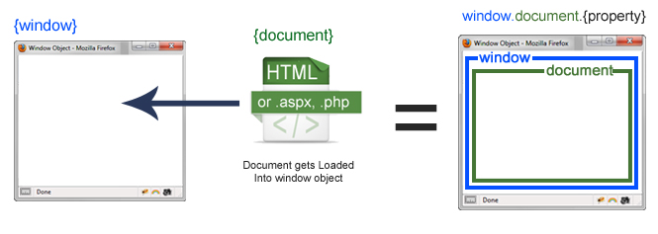

Screen:
Screen is a small information object about physical screen dimensions. It can be used to display screen width, height, color Depth, pixel Depth etc. It is not mandatory to write window prefix with screen object. It can be written without window prefix.
Document:
The Document interface represents any web page loaded in the browser and serves as an entry point into the web page's content, which is the DOM tree. When an HTML document is loaded into a web browser, it becomes a document object. It is the root node of the HTML document. The document actually gets loaded inside the window object and has properties available to it like title, URL, cookie, etc. HTML documents, served with the "text/html" content type, also implement the HTML Document interface, whereas XML and SVG documents implement the XML Document interface.

